1 – 2. Function Domains – Teaching Set

1. [P] What’s the (apparent) domain and range of each graph?
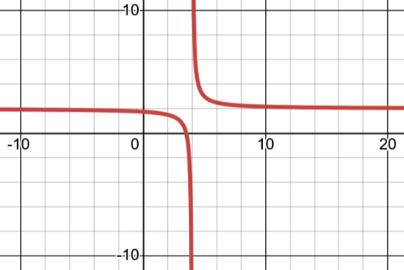
  - This is a transformed exponential b. This is a transformed $\frac{1}{x}$ function
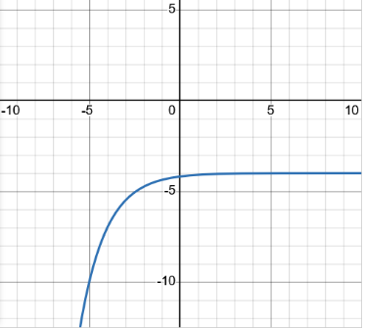

2. [P] Some (hopefully!) straightforward ones to get your feet under you.
- Find the domain of $a\left(x\right)=\frac{1}{x+7}$
- Find the domain of $b(x)=2^{x}$
- Find the domain of $c\left(x\right)=\sqrt{5-2x}$
[Remember, if you have $\sqrt{stuff}$ , then you know $stuff≥0$ . Solve for the x-value(s) which make that true! ]
- Find the domain of $d\left(r\right)=\frac{\sqrt{2+r}}{r-10}$
- Find the domain of $f\left(x\right)=\frac{x-10}{\sqrt{2+x}}$
- Find the domain of $g\left(w\right)=\sqrt[9]{w-1}$ [ hint: think of the graph]
- Find the domain of $h\left(x\right)=\frac{1}{(x-1)(x-2)}+\sqrt{x}$
- Find the domain of $m\left(t\right)=\sqrt{t^{2}+1}$

3. [P] You can show domain visually on a numberline.
For example, the domain of $\frac{\sqrt{2+x}}{x-10}$ is

a. Find the domain of $f\left(x\right)=\frac{\sqrt{6-x} + \sqrt{x-4}}{x^{2}-25}$ . Write it and show it visually.
b. Find the domain of $g\left(x\right)=\frac{2^{x} - 5^{x}}{{\left(\sqrt[3]{x}\right)}^{2}+1}$ .
c. Find the domain of $p\left(x\right)=\frac{(x-1)}{\left(x-1\right) - \frac{1}{x -1}}$ . Write it and show it visually.
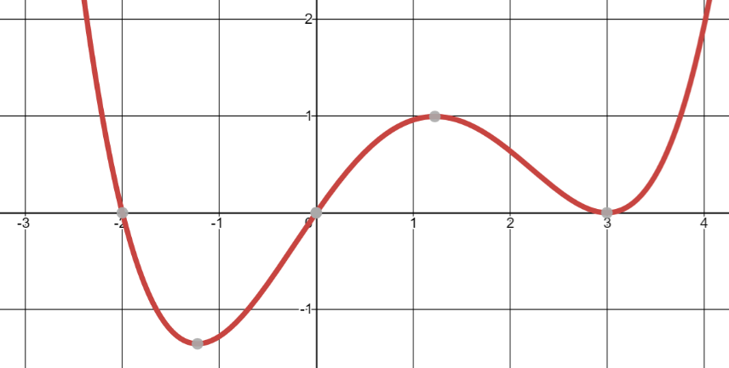
4. [C]
a. The function here is $y=f(x)$.
What do you know about the domain of $\frac{1}{f(x)}$ vs $\frac{1}{\sqrt{f(x)}}$ ?

[hint: think what would make $\frac{1}{f\left(x\right)}$ undefined – what does it mean, in general. Look at the graph to decide when that might happen for this particular $f(x)$ ]

Topic 1 – 2. Function Domains – Solutions
1. [P] This question was just making sure you know what domain and range are talking about. Domain is the set of all x values which produce valid outputs for the function. Graphically, those will be all the x-values for points on the graph. Range is the set of outputs the function can have. Graphically, the set of y-values in the graph.

a). Domain: all real values, range: $y<-4$ b). domain $x≠4$, range: $y≠2$

2. [P] The key to all of these is to remember two key things: $f(x)=\sqrt[even]{thing}$ then, for the output to be defined, thing can’t be negative. So, for example, in $f\left(x\right)=\sqrt[12]{1-x^{3}}$ , we know $1-x^{3}≥0$. Re-organzing this gives $1≥x^{3}$ which is the same as $1≥x$.

Second, if you have $f\left(x\right)=\frac{1}{thing}$ then you know that $thing$ can’t be 0.

a. Find the domain of $a\left(x\right)=\frac{1}{x+7}$ $x+7≠0$, so $x≠7$
b. Find the domain of $b(x)=2^{x}$ all real numbers, since all inputs have valid outputs
c. Find the domain of $c\left(x\right)=\sqrt{5-2x}$ $5-2x≥0$ , so $x≤\frac{5}{2}$
d. Find the domain of $d\left(r\right)=\frac{\sqrt{2+r}}{r-10}$
This has two ways it might be undefined. If $2+r$ is negative, or if $r-10$ is 0.
That gives us that $2+r≥0$ and $r-10≠0$. Re-organizing gives us $r≥-2$ and $r≠10$.

e. Find the domain of $f\left(x\right)=\frac{x-10}{\sqrt{2+x}}$
This one also has two restrictions: $2+x$ must be 0 or larger. Also: $\sqrt{2+x}$ can’t be 0. Putting those together gives $\sqrt{2+x}>0$ (strictly larger than 0). That gives: $x>-2$. Be sure you’re clear in your mind why x can’t be equal to -2. (what happens if you plug it in?)

f. Find the domain of $g\left(w\right)=\sqrt[9]{w-1}$
Since this is an odd root, it’s perfectly fine if the inside is a negative value. Put differently, there is no input to an odd root that would cause it to be undefined. So the answer is all real numbers.

g. Find the domain of $h\left(x\right)=\frac{1}{(x-1)(x-2)}+\sqrt{x}$
There are several ways this might be undefined. If $x=1$ or $x=2$ then $\frac{1}{(x-1)(x-2)}$ will be undefined. If $x<0$ then $\sqrt{x}$ will be undefined. So the answer is: $x>0$ and $x≠1$ or $x≠2$.

h. Find the domain of $m\left(t\right)=\sqrt{t^{2}+1}$
For this you you might thing: “I know $t^{2}+1≥0$”. If you think about it, $t^{2}$ can’t be negative, so $t^{2}+1$ is always going to be 1 or larger. So the condition is always satisfied. $t^{2}+1$ can never be negative, no matter what t is. Therefore the answer is the domain is all real numbers.

3. [P] You can show domain visually on a numberline.
For example, the domain of $\frac{\sqrt{2+x}}{x-10}$ is

a. Find the domain of $f\left(x\right)=\frac{\sqrt{6-x} + \sqrt{x-4}}{x^{2}-25}$ . Write it and show it visually.

Let’s look at each part separately. In the denominator, if $x=5$ or $-5$ the denominator is 0, so we know $x≠±5$. We know $6-x≥0$ leading to $6≥x$. We also know $x-4≥0$, leading to $x≥4$.

b. Find the domain of $g\left(x\right)=\frac{2^{x} - 5^{x}}{{\left(\sqrt[3]{x}\right)}^{2}+1}$ .
There is no domain restriction from the numerator. In the denominator, it’s ok for x to be negative in $\sqrt[3]{x}$. We also know that ${\left(\sqrt[3]{x}\right)}^{2}+1$ can’t be 0 since the squared term is 0 or larger, and then we add 1 to it. Therefore the domain here is all real numbers.

c. Find the domain of $p\left(x\right)=\frac{(x-1)}{\left(x-1\right) - \frac{1}{x -1}}$ . Write it and show it visually.
We know $x≠1$ since that would make the denominator of $\frac{1}{x-1}$ equal to 0. We also know that $\left(x-1\right)-\frac{1}{x-1}≠0$. Let’s solve for x: $x-1≠\frac{1}{x-1}$ ${\left(x-1\right)}^{2}≠1$ $x-1≠1$ so $x≠2$.

4. [C]

To think about the domain of $\frac{1}{f(x)}$, we need to ask: when would this be undefined? I know that the denominator can’t be 0. So that means $f(x)$ can’t output 0. Looking at the graph, we see that $y=f(x)$ outputs 0 at x = -2, 0 and 3.

Therefore the domain of $\frac{1}{f(x)}$ is $x≠-2, 0, 3$

What about the domain of $\frac{1}{\sqrt{f(x)}}$ ? Here we also know that $f\left(x\right)≥0$. So when does that happen? Looking at the graph, only when $x≤-2$ or $0≤x$. Put that together with the last result, and we have that the domain is $x<-2$ or $0<x$ with $x≠3$.

